Asian Parliamentary Assembly
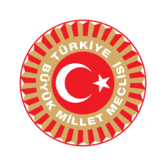 | APA Working Group on Statutory Documents  (First Session)  Ürgüp-NEVŞEHİR, Turkey  11-14 October 2021 | 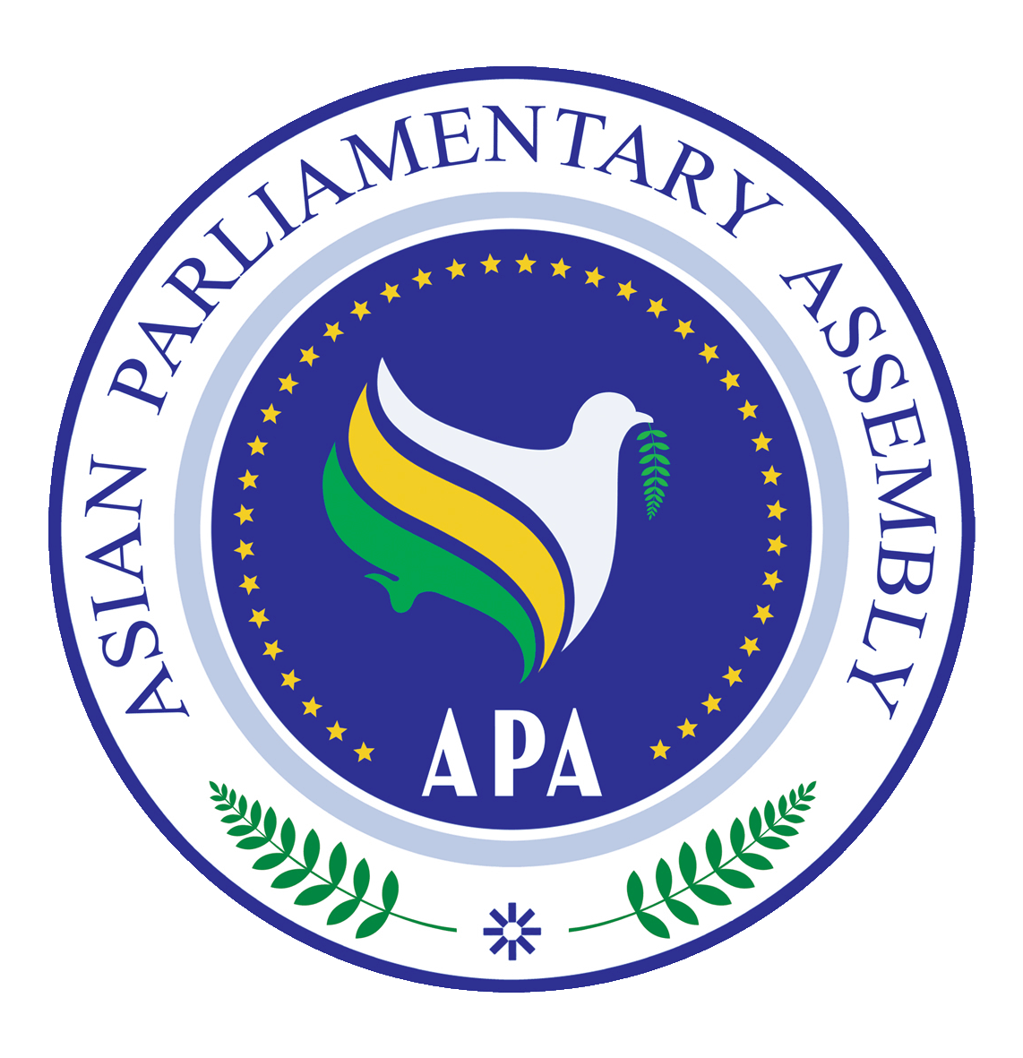
Registration Form

Please fill in one form for each participating delegate in CAPITAL letters, and submit the form by 04 October 2021.
Delegation of: ………………………………
Name of Parliament

Title: Mr. Ms. Dr.
First Name:
Last Name:

Position: …………………………………… Head of delegation Member of delegation
- Please indicate if you are the Head of delegation
Passport No: Date of birth (d/m/y) Place of birth (City, Country)
………………………..…

Passport issue date: Passport expiry date: Place of visa issuance (City, Country)

……………………………….

Tel No. | …………………..……………………………………………..  Country Code - City Code - Number
Mobile No.
Fax No.
Email Address:
Flight Details

 | Date | Airline & Flight number | Time | Explanation
Arrival
Departure
Please forward (fax or e-mail) the completed form to both the Host Secretariat as well as CC to the APA Secretariat:

Host Secretariat:
CC to APA Secretariat:
Email :secretariat@asianparliament.org
Fax : (+98-21) 33517408
Phone : (+98-21) 33517406-7

Email: apaturkey@tbmm.gov.tr

Tel : (+90) 312 420 8170
(+90) 312 420 6757
(+90) 312 420 6752

Asian Parliamentary Assembly
APA Working Group on Statutory Documents
(First Session)
Ürgüp-NEVŞEHİR, Turkey
11-14 October 2021
To facilitate our preparations to issue the identification Badges please complete and return this form together with the Registration Form
Delegation of: ………………………………
Name of Parliament

No. | First Name | Last Name | Position | Photo
Host Secretariat:  Email: apaturkey@tbmm.gov.tr  Tel : (+90) 312 420 8170  (+90) 312 420 6757  (+90) 312 420 6752 | CC to APA Secretariat:  Email :secretariat@asianparliament.org  Fax : (+98-21) 33517408  Phone : (+98-21) 33517406-7

